**Project Name:** Detecting Parkinson’s Disease

**Github Link:** https://github.com/utkrisht2000/Detecting-Parkinson-s-disease.git

**Why was this project created?**

Because of its underlying cognitive and neuro-muscular function, biomarkers extracted from human voice can provide insight into neurological illnesses like Parkinson's disease. About one million people in the US suffer from this progressive neurological condition. It has proved challenging to define, and doctors frequently rely on arbitrary grading scales and focus on some symptoms while neglecting others.

**What problem is it solving?**

Parkinson's disease affects movement, causes tremors and stiffness, and is a progressive illness of the central nervous system. It comprises five stages and affects more than 1 million people in India each year. There is currently no treatment for this chronic condition. It is a neurodegenerative condition that affects brain cells that make dopamine. So we build a model to accurately detect the presence of Parkinson’s disease in an individual.

**Entire explanation of project**

* **PROPOSED APPROACH**

Parkinson’s disease affects the CNS of the brain and has yet no treatment unless it’s detected early. Late detection leads to no treatment and loss of life. Thus its early detection is significant. For early detection of the disease, we utilized machine learning algorithms such as XGBoost and Random Forest. We checked our Parkinson disease data and found out XGBoost is the best Algorithm to predict the onset of the disease which will enable early treatment and save a life.

A new machine learning method called XGBoost was created with performance and speed in mind. Extreme Gradient Boosting, or XGBoost, is a decision tree-based algorithm. The XGBClassifier, an implementation of the scikit-learn API for XGBoost classification, will be imported into this project from the xgboost library. We will construct a model using an XGBClassifier utilizing the python packages scikit-learn, numpy, pandas, and xgboost. After loading the data, obtaining the features and labels, scaling the features, splitting the dataset, and creating an XGBClassifier, we will determine the model's correctness.

Algorithm for creating next word prediction model :

**Step 1:** Dataset is imported

**Step 2:** The data is preprocessed, and the dataset is split into training and testing.

**Step 3:** Feature Extraction

**Step 5:** Normalization

**Step 6:** Initialize an XGBClassifier and train the model

**Step 7:** Calculate Accuracy

* **DATA FLOW DIAGRAM**

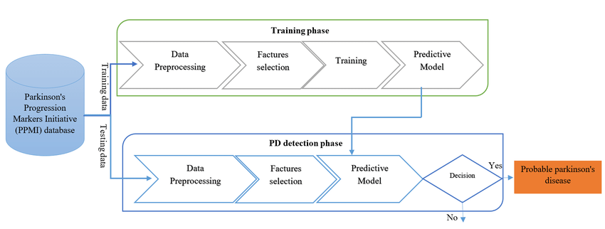

* **RESULT**

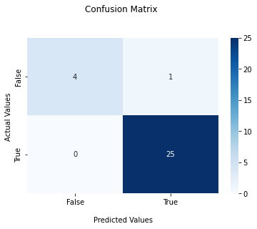

* **CONCLUSION**

This project detects the presence of Parkinson’s Disease in individuals using various factors. We used an XGBClassifier for this and made use of the sklearn library to prepare the dataset. This gives us an accuracy of 94.87%.